Asymmetric DCC correlation: AUDUSD and USDCHF
Method 10 / GARCH(1,1) + Cappiello-Engle-Sheppard ADCC / Alpari D1 full available history

Study setup
Logical pair: AUDUSD , USDCHF
Broker symbols: AUDUSD_i , USDCHF_i
Snapshot: 2026-11-03_majors_alpari_D1
Timeframe: D1
Matched return window: 1999-01-05 to 2026-11-02 (UTC bar dates)
Matched return count n: 7200
Dropped unfinished last bar dated 2026-11-03 UTC after a tick-volume check against the prior complete day.
AUDUSD GARCH(1,1): mu=0.000036, omega=0.005406, alpha=0.052155, beta=0.937245
USDCHF GARCH(1,1): mu=-0.000354, omega=0.003267, alpha=0.042733, beta=0.955789
ADCC: a=0.049570, b=0.924292, g=0.000000, a+b+g/2=0.973863
Nested DCC (g=0): a=0.049570, b=0.924292
Negative shock: n = min(z, 0) in broker quote direction (not inverted)
Burn-in ignored in path summaries and chart: first 60 updates
Complete matched rows (Excel): AUDUSD-USDCHF_ADCC_D1.xlsx
Complete matched rows (HTML table): AUDUSD-USDCHF_ADCC_D1_data.html

Method carried forward
Asymmetric DCC extends Engle DCC with an extra term on joint negative standardised shocks. Each matched daily log return of close, ln(close_t / close_t-1), is first filtered by a constant-mean GARCH(1,1). Then z = residual / sigma and n = min(z, 0). The Cappiello-Engle-Sheppard recursion uses A = (1-a-b) Q_bar - g N_bar with N_bar = mean(n n'). Quotes are not inverted, so a negative shock is a negative log return in the broker quote. Nested symmetric DCC (g = 0) is fit on the same z path for comparison. Constraints: a,b,g >= 0 and a + b + g/2 < 1. Path summaries ignore the first 60 updates. The headline is latest ADCC rho. Pearson r is a side check only. This is not a cause, lead, or trading signal.

Results
Latest ADCC rho: -0.121292
Latest nested DCC rho: -0.121291
Post-burn-in ADCC path (n=7140): mean=-0.419801, median=-0.442795, min=-0.764877, max=0.296659, std=0.155770
Share of post-burn-in days with |rho| >= 0.4: 60.00%; |rho| >= 0.7: 0.63%
Same-sample Pearson r: -0.380878
ADCC minus r: 0.259587
ADCC minus nested DCC: -0.000000

Conclusion
Over 7200 matched daily log-return rows for AUDUSD and USDCHF (broker quote directions unchanged), latest ADCC rho is -0.1213 (negative, weak conditional linear link in this sample) with fitted a=0.0496, b=0.9243, g=0.0000. Nested symmetric DCC latest rho is -0.1213 (ADCC minus DCC = -0.0000). After a 60-day burn-in, path mean is -0.4198 and std is 0.1558. Same-sample Pearson r is -0.3809 (ADCC minus r = 0.2596). This does not establish cause, lead-lag, or a lasting trading rule.

Charts
Daily closes

Daily log returns
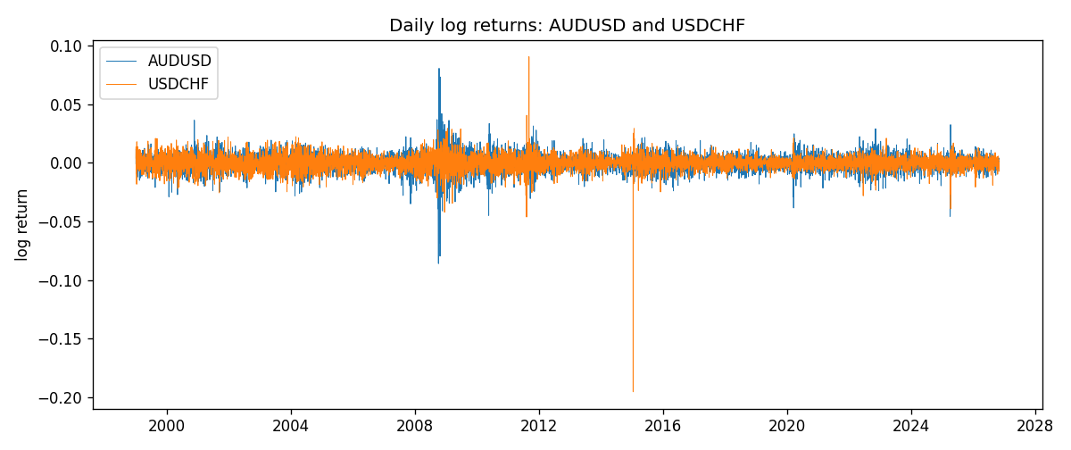
ADCC rho path with nested DCC and Pearson r
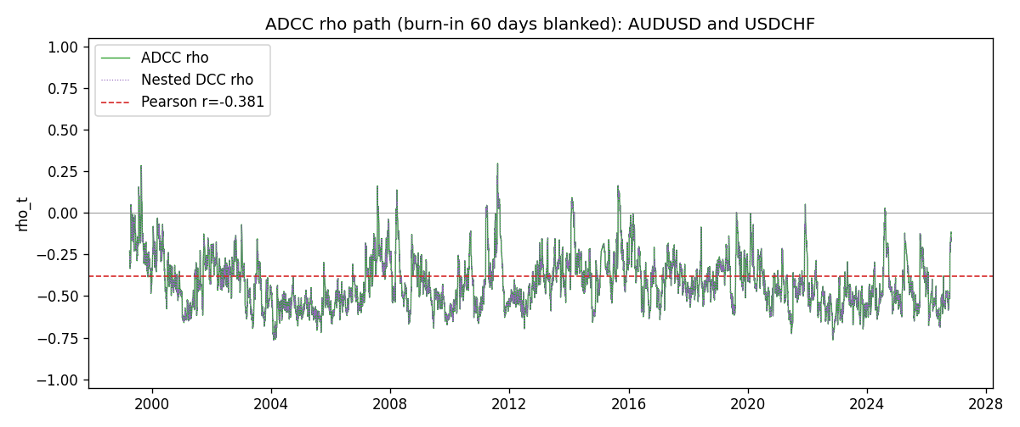

Data report
Every matched row that entered the ADCC recursion is stored in the sibling Excel workbook named AUDUSD-USDCHF_ADCC_D1.xlsx. Embedding all rows as a Word table is impractical at this length; the Word file holds the column list, column summaries, and the first and last 15 matched rows.
Columns: time, AUDUSD_open, USDCHF_open, AUDUSD_high, USDCHF_high, AUDUSD_low, USDCHF_low, AUDUSD_close, USDCHF_close, AUDUSD_tick_volume, USDCHF_tick_volume, AUDUSD_spread, USDCHF_spread, AUDUSD_real_volume, USDCHF_real_volume, AUDUSD_log_return, USDCHF_log_return, AUDUSD_sigma, USDCHF_sigma, AUDUSD_z, USDCHF_z, AUDUSD_n, USDCHF_n, q11, q22, q12, rho_adcc, rho_dcc
Column summaries (matched calculation rows)
column | count | mean | std | min | 25% | 50% | 75% | max
AUDUSD_open | 7200 | 0.7519587 | 0.13528421 | 0.4785 | 0.6610975 | 0.731415 | 0.8091275 | 1.10284
USDCHF_open | 7200 | 1.0982244 | 0.25258622 | 0.72022 | 0.920675 | 0.990175 | 1.238625 | 1.8219
AUDUSD_high | 7200 | 0.75601148 | 0.13584385 | 0.4878 | 0.6647 | 0.734785 | 0.8152525 | 1.10795
USDCHF_high | 7200 | 1.1035234 | 0.25433538 | 0.73305 | 0.9249475 | 0.99377 | 1.2436 | 1.8313
AUDUSD_low | 7200 | 0.74790307 | 0.1345988 | 0.4775 | 0.65778 | 0.727495 | 0.804225 | 1.0975
USDCHF_low | 7200 | 1.0930985 | 0.25099871 | 0.08565 | 0.917415 | 0.98668 | 1.232725 | 1.8121
AUDUSD_close | 7200 | 0.75201172 | 0.13526687 | 0.4786 | 0.6612 | 0.731695 | 0.8091975 | 1.10169
USDCHF_close | 7200 | 1.0982149 | 0.25248642 | 0.72025 | 0.92097 | 0.990145 | 1.238625 | 1.8217
AUDUSD_tick_volume | 7200 | 77358.386 | 138142.18 | 109 | 5440 | 43334.5 | 71332.25 | 1234623
USDCHF_tick_volume | 7200 | 74199.562 | 113414.45 | 350 | 12776 | 40195 | 70261.25 | 858589
AUDUSD_spread | 7200 | 30.817222 | 16.887144 | 0 | 13 | 30 | 50 | 50
USDCHF_spread | 7200 | 26.104306 | 24.710129 | 0 | 5 | 16 | 50 | 100
AUDUSD_real_volume | 7200 | 5.2428187e+09 | 1.2538918e+11 | 0 | 0 | 0 | 0 | 3.811512e+12
USDCHF_real_volume | 7200 | 2.3239785e+10 | 8.9047261e+10 | 0 | 0 | 0 | 0 | 1.9331921e+12
AUDUSD_log_return | 7200 | 2.837e-05 | 0.00754598 | -0.08602525 | -0.00385535 | 0.0002835 | 0.00415437 | 0.0806166
USDCHF_log_return | 7200 | -7.168e-05 | 0.00659376 | -0.19545699 | -0.00336083 | 8.057e-05 | 0.00331954 | 0.09051364
AUDUSD_sigma | 7200 | 0.00694155 | 0.00279112 | 0.00391205 | 0.00551453 | 0.00626907 | 0.00758507 | 0.03849455
USDCHF_sigma | 7200 | 0.00655218 | 0.002589 | 0.0035461 | 0.00506174 | 0.00610733 | 0.00733969 | 0.04071881
AUDUSD_z | 7200 | -0.00456916 | 1.0001148 | -8.4753292 | -0.60437795 | 0.03987211 | 0.63649341 | 5.0218131
USDCHF_z | 7200 | 0.04140645 | 0.99903014 | -34.238178 | -0.4819698 | 0.07217528 | 0.59884428 | 6.6801901
AUDUSD_n | 7200 | -0.38806296 | 0.62454597 | -8.4753292 | -0.60437795 | 0 | 0 | 0
USDCHF_n | 7200 | -0.33023628 | 0.67753379 | -34.238178 | -0.4819698 | 0 | 0 | 0
q11 | 7200 | 1.0004813 | 0.25429387 | 0.59287521 | 0.84847479 | 0.95271546 | 1.0828992 | 4.4006269
q22 | 7200 | 1.0001112 | 1.7878998 | 0.52918956 | 0.76305694 | 0.8614111 | 0.98811379 | 58.869372
q12 | 7200 | -0.39552891 | 0.18735392 | -2.7856327 | -0.50429504 | -0.38607904 | -0.28416784 | 0.52883481
rho_adcc | 7200 | -0.4170572 | 0.15816481 | -0.76487727 | -0.53600662 | -0.44128923 | -0.32337241 | 0.29665876
rho_dcc | 7200 | -0.4170572 | 0.15816485 | -0.76487739 | -0.53600661 | -0.44128925 | -0.32337245 | 0.29665897
First 15 matched rows (selected columns)
time | AUDUSD_log_return | USDCHF_log_return | AUDUSD_z | USDCHF_z | AUDUSD_n | USDCHF_n | q11 | q22 | q12 | rho_adcc | rho_dcc
1999-01-05 | -0.00080418179 | 0.0039424743 | -0.13361965 | 0.512148 | -0.13361965 | 0 | 1 | 1 | -0.39496174 | -0.39496174 | -0.39496174
1999-01-06 | 0.011836351 | 0.013605652 | 1.9238312 | 1.688175 | 0 | 0 | 0.95131479 | 0.9634318 | -0.37877563 | -0.39564841 | -0.3956484
1999-01-07 | 0.0088650256 | -0.0093883841 | 1.3453976 | -1.0501968 | 0 | -1.0501968 | 1.0888961 | 1.057902 | -0.19943024 | -0.18581256 | -0.18581235
1999-01-08 | 0.00031515916 | 0.011040268 | 0.041644699 | 1.3196421 | 0 | 0 | 1.1223226 | 1.0586198 | -0.2646945 | -0.24283767 | -0.24283753
1999-01-11 | 0.0072213815 | 0.0052963193 | 1.0997193 | 0.6433564 | 0 | 0 | 1.0635776 | 1.090936 | -0.25225417 | -0.23418234 | -0.2341822
1999-01-12 | -0.0048608485 | -0.0098275602 | -0.74461475 | -1.0909581 | -0.74461475 | -1.0909581 | 1.0691434 | 1.0549987 | -0.20840834 | -0.1962326 | -0.19623243
1999-01-13 | -0.0078902098 | -0.018259701 | -1.2183379 | -2.0507392 | -1.2183379 | -2.0507392 | 1.0418228 | 1.0602626 | -0.16268542 | -0.15479074 | -0.15479054
1999-01-14 | -0.002696916 | -0.0024256692 | -0.41441969 | -0.22225927 | -0.41441969 | -0.22225927 | 1.0626657 | 1.2145993 | -0.036841174 | -0.032427884 | -0.032427618
1999-01-15 | 0.007123101 | 0.01794228 | 1.0976911 | 2.0014733 | 0 | 0 | 1.0168646 | 1.151231 | -0.0398094 | -0.036793647 | -0.036793392
1999-01-18 | 0.00094592471 | -0.0031856384 | 0.14003776 | -0.29130452 | 0 | -0.29130452 | 1.025746 | 1.2887846 | 0.061787044 | 0.053738721 | 0.053739033
1999-01-19 | 0.0072225153 | -7.2518946e-05 | 1.1339848 | 0.029489762 | 0 | 0 | 0.97519868 | 1.2215577 | 0.04476392 | 0.041013286 | 0.04101358
1999-01-20 | 0.0012507819 | 0.0072259871 | 0.19001771 | 0.81124513 | 0 | 0 | 0.99124952 | 1.1552569 | 0.032709401 | 0.030566225 | 0.030566493
1999-01-21 | 0.00078094498 | -0.0038232689 | 0.11941131 | -0.37363834 | 0 | -0.37363834 | 0.94413157 | 1.1265557 | 0.027551124 | 0.026714481 | 0.026714737
1999-01-22 | -0.012252745 | -0.0001445609 | -2.0187024 | 0.02293467 | -2.0187024 | 0 | 0.8994978 | 1.0743245 | 0.01293041 | 0.013153596 | 0.013153832
1999-01-25 | -0.0039591468 | 0.0024546976 | -0.60819589 | 0.31420019 | -0.60819589 | 0 | 1.059543 | 1.0191534 | -0.00066676527 | -0.00064164364 | -0.00064144938
Last 15 matched rows (selected columns)
time | AUDUSD_log_return | USDCHF_log_return | AUDUSD_z | USDCHF_z | AUDUSD_n | USDCHF_n | q11 | q22 | q12 | rho_adcc | rho_dcc
2026-10-13 | 0.0035007712 | -0.0024955621 | 0.76675009 | -0.45184001 | 0 | -0.45184001 | 0.7801684 | 0.70224117 | -0.3763384 | -0.50844176 | -0.50844174
2026-10-14 | -0.0015193215 | 0.0029388325 | -0.34512774 | 0.70203751 | -0.34512774 | 0 | 0.77638369 | 0.68533374 | -0.37534351 | -0.5145643 | -0.51456429
2026-10-15 | -0.0075447063 | -0.0097855323 | -1.7080078 | -2.0193603 | -1.7080078 | -2.0193603 | 0.74964735 | 0.68401712 | -0.36926091 | -0.51566939 | -0.51566937
2026-10-16 | 0.0033906408 | -0.0036230826 | 0.71523875 | -0.65413205 | 0 | -0.65413205 | 0.86364152 | 0.86050754 | -0.18065637 | -0.20956038 | -0.20956012
2026-10-19 | 0.0050859986 | 0.0036351779 | 1.0829386 | 0.80331757 | 0 | 0 | 0.84975311 | 0.84270848 | -0.20049452 | -0.23692857 | -0.23692835
2026-10-20 | 0.0034620426 | -0.0026281224 | 0.72629846 | -0.45878294 | 0 | -0.45878294 | 0.86969149 | 0.837035 | -0.15251548 | -0.17875554 | -0.17875527
2026-10-21 | 0.0036066384 | -0.00040027413 | 0.76112969 | -0.0094750746 | 0 | -0.0094750746 | 0.85613534 | 0.81023607 | -0.16780961 | -0.20148365 | -0.20148342
2026-10-22 | -0.0012672558 | -0.0048036381 | -0.27889009 | -0.92186231 | -0.27889009 | -0.92186231 | 0.84617369 | 0.77503682 | -0.16578587 | -0.20471826 | -0.20471804
2026-10-23 | 0.0023765656 | 0.005652514 | 0.50965707 | 1.2405291 | 0 | 0 | 0.8121048 | 0.78462427 | -0.15081343 | -0.18893095 | -0.18893073
2026-10-26 | -0.0032032829 | 0.0018407959 | -0.71376152 | 0.44543403 | -0.71376152 | 0 | 0.78963552 | 0.82764386 | -0.11837844 | -0.14643251 | -0.14643226
2026-10-27 | 0.0016669876 | 0.0026100526 | 0.36121573 | 0.6083807 | 0 | 0 | 0.78124529 | 0.80095757 | -0.13549958 | -0.17129295 | -0.17129273
2026-10-28 | 0.0040915541 | -0.0010142111 | 0.91166993 | -0.13655758 | 0 | -0.13655758 | 0.75470418 | 0.78480362 | -0.12467107 | -0.16199321 | -0.161993
2026-10-29 | -0.0040915541 | -0.0048680164 | -0.92415924 | -0.94751366 | -0.92415924 | -0.94751366 | 0.76490459 | 0.75244974 | -0.13172703 | -0.1736331 | -0.17363291
2026-10-30 | 0.0010102376 | 0.00071594559 | 0.21719833 | 0.22358671 | 0 | 0 | 0.77546931 | 0.7661242 | -0.088671163 | -0.11504043 | -0.1150402
2026-11-02 | -0.0049184984 | -0.0071459744 | -1.1233568 | -1.4397494 | -1.1233568 | -1.4397494 | 0.74523621 | 0.73673817 | -0.089874054 | -0.12129161 | -0.12129139

